Mendelian Genetics Game Development
Project Managers
Marjee Chimel
Amos Simms-Smith
Trevor Owens
9/29/2009

This document provides an overview of both the needs and task analysis necessary to design a game that teaches the fundamentals of Mendelian genetics.

Table of Contents
Needs Analysis: 3
Needs Analysis Plan 3
Needs Analysis Summary 4
Needs Analysis Data 4
Relevant Standards 4
Student Scores on Standardized Tests: 6
Survey of Existing Web Course Materials: 7
Interview with Middle School Science Teacher: 10
Task Analysis 11
TASK Analysis Plan 11
TASK Analysis SUMMARY 11
TASK Analysis DATA 12
Learning Goals 11
Levels of Learning 11
Processing Analysis 11
Tasks to Achieve Goals 14
Revised Learning Goals 15
LEARNER Analysis: 16
Learner Analysis Plan 16
learner Analysis results 18
learner Analysis survey 18
context Analysis: 20
Learning Context 20
Performance context 20

Designs: 21
Instructional Goals 21
Objectives 22
Description of Learning Environments………..………………………………………………………..……23
Activities…………………………………………………………………………………………………………………..26

Assessment: 27
Learner Assessment 27
Formative Assessment 29
Summative Evaluation 30

This document provides an overview the needs and analysis necessary to design a game that teaches the fundamentals of Mendelian genetics.

© 2009

Needs Analysis:
Allison Rossett’s Five-Step Approach
The state of Virginia has requested the help of our development team in resolving a specific problem they are having with their virtual middle school curriculum. To begin the process of rectifying this issue we are using Allison Rossett’s Five-Step Approach for conducting a needs analysis. This approach is particularly powerful for responding to a request, like Virginia’s request, for assistance.

Needs Analysis Plan
Step 1: Determine purpose on the basis of initiators
Virginia Virtual is having a difficult time teaching students about Mendelian inheritance. In a traditional classroom, students conduct labs to recreate the process allowing students to rediscover the laws of inheritance, but Virginia has been using textual descriptions of the process to teach the students and they are not learning the content or demonstrating an understanding of the nature of science in their reactions to the content. They have contracted with us to develop a virtual lab to address these instructional concerns.

Step 2: Identify sources
To satisfy our requirements we will need to analyze several different sources.
- Relevant state and national standards content standards to be considered
- Relevant broader national standards to be considered
- Existing curricular materials
- Middle school science teacher
- Student scores on standardized tests

Step 3: Select tools
Each of the sources clearly requires distinct tools. The team will interview the middle school science teacher, to develop a table of the state and national standards, and read through and assess the existing curricular materials in light of the table of standards.

Step 4: Conduct the needs assessment in stages
The team will organize the table of standards and the assessment of curricular materials before the interview to allow the middle school science teacher to comment on both of those sets of information.

Needs Analysis Summary
This section reports the results of the Needs Analysis. Below you will find information on the needs for this project. The section includes information about state and national standards, a brief report on student test scores, an analysis of existing web course content and the results of an interview with a middle school science teacher who teaches both face-to-face classes and virtual courses in middle school science in the state of Virginia.
The needs analysis suggests that the approach Virginia Virtual has suggested, developing an interactive which explicitly aims to engage students in understanding both the core content and the nature of science and scientific inquiry is necessary. A significant portion of the standards focus on nature of science and scientific inquiry, and the teacher reports that this is difficult to communicate in the online courses. This need is further evident in the fact that the students in the virtual courses are not as successful on the state tests as the students in face-to-face courses.

Needs Analysis Data

Relevant Standards
Content Standards:
National Science Education Standards 5-8:
C.2. Reproduction and heredity
C.2.a. Reproduction is a characteristic of all living systems
C.2.c. Every organism requires a set of instructions for specifying its traits
C.2.e. The characteristics of an organism can be described in terms of a combination of traits
VA SOLs LS.13
The student will investigate and understand that organisms reproduce and transmit genetic information to new generations. Key concepts include
c) genotypes and phenotypes;
d) factors affecting the expression of traits;
e) characteristics that can and cannot be inherited;
g) historical contributions and significance of discoveries related to genetics.
Broader National Standards
A.1. | Abilities necessary to do scientific inquiry
A.1.a. | Identify questions that can be answered through scientific investigations.
A.1.b. | Design and conduct scientific investigations.
A.1.c. | Use appropriate tools and techniques to gather, analyze and interpret data.
A.1.d. | Develop descriptions, explanations, predictions, and models using evidence.
A.1.e. | Think Critically and logically to make relationships between evidence and explanations.
A.1.f. | Recognize and analyze alternative explanations and predictions.
A.1.g. | Communicate scientific procedures and explanations.
A.1.h. | Use mathematics in all aspects of scientific inquiry.
A.2. | Understandings about scientific inquiry
A.2.a. | Different kinds of questions suggest different kinds of scientific investigations
A.2.b. | Current scientific knowledge and understanding guide scientific investigations
A.2.c. | Mathematics is important in all aspects of scientific inquiry
A.2.d. | Technology used to gather data enhances accuracy and allows scientists to analyze and quantify results of investigations
A.2.e. | Scientific explanations emphasize evidence, have logically consistent arguments, and use scientific principles, models, and theories
A.2.f. | Science advances through legitimate skepticism
A.2.g. | Scientific investigations sometimes result in new ideas and phenomena for study, generate new methods or procedures for an investigation, or develop new technologies to improve the collection of data

G.1. | Science as a human endeavor
G.1.a. | Women and men of various social and ethnic backgrounds--and with diverse interests, talents, qualities, and motivations--engage in the activities of science, engineering, and related fields such as the health professions
G.1.b. | Science requires different abilities, depending on such factors as the field of study and type of inquiry
G.2. | Nature of science
G.2.a. | Scientists formulate and test their explanations of nature using observation, experiments, and theoretical and mathematical models
G.2.b. | In areas where active research is being pursued and in which there is not a great deal of experimental or observational evidence and understanding, it is normal for scientists to differ with one another about the interpretation of the evidence or theory being considered
G.2.c. | It is part of scientific inquiry to evaluate the results of scientific investigations, experiments, observations, theoretical models, and the explanations proposed by other scientists
G.3. | History of science
G.3.a. | Many individuals have contributed to the traditions of science
G.3.b. | In historical perspective, science has been practiced by different individuals in different cultures
G.3.c. | Tracing the history of science can show how difficult it was for scientific innovators to break through the accepted ideas of their time to reach the conclusions that we currently take for granted

Student Scores on Standardized Tests:
Students in the Virginia Virtual courses are not doing as well as the students in face to face courses. The students in the virtual schools are showing slightly lower rates of success on the content portions of the state tests, but they are showing particularly poor results on the portions of the state tests which gauge student understanding of scientific inquiry and the nature of science.

Survey of Existing Web Course Materials:
1) Mendel’s Genetics
Creator: Dennis O'Neil Behavioral Sciences Department, Palomar College, http://anthro.palomar.edu/mendel/mendel_1.htm
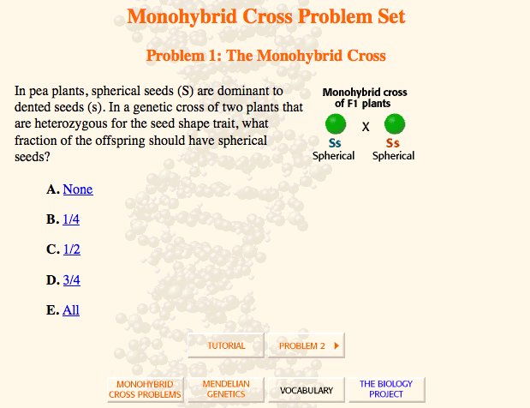
O’Neil’s presentation of genetics is sound. He covers the content in a rigorous and quick fashion. However, the module illustrates many of the problems Virginia Virtual is having with the instruction. The module presents science as a “rhetoric of conclusions,” science is presented as a series of facts, not a presentation of how scientific ideas and theories are created.

2) The Biology Project
Creator: University of Arizona
http://www.biology.arizona.edu/mendelian_genetics/mendelian_genetics.html
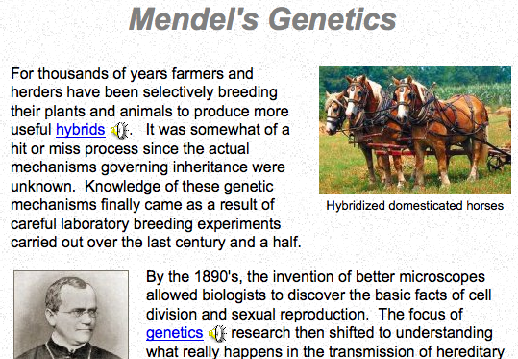
The Biology Project has created an extensive set of web courses. The content is similar to Denis O’Neil’s and the presentation reflects many of the same problems. In contrast to O’Neil’s module this one incorporates some levels of student interactivity. Throughout the web course students can participate in different multiple choice quizzes. These quizzes, however, are still divorced from the kinds of inquiry and nature of science standards that Virginia Virtual wants to better support.

3) Replicators: Evolutionary Powerhouses
Creator: ThinkQuest by Oracle
http://library.thinkquest.org/C004367/be1.shtml
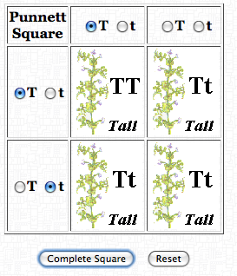
Like the two previous examples this course is a primarily text based presentation of genetics content. A significant portion of the course materials focuses on Mendel and his discoveries. This presentation suffers from the same problems as previously discussed units. It does not support authentic inquiry or understanding of the nature of science in the way Virginia Virtual wants their interactive to. With that noted, this module did include a very basic interactive which allows students to generate Punnett Squares (Figure One). This presentation still suffers from the same issues as the rest of the content, however, it is a valuable example of how some of the pieces of the content can serve as a basis for a new interactive.

4. Web Lab: Mendel’s Peas
Creator: Concord Consortium
http://biologica.concord.org/webtest1/web_labs_mendels_peas.htm
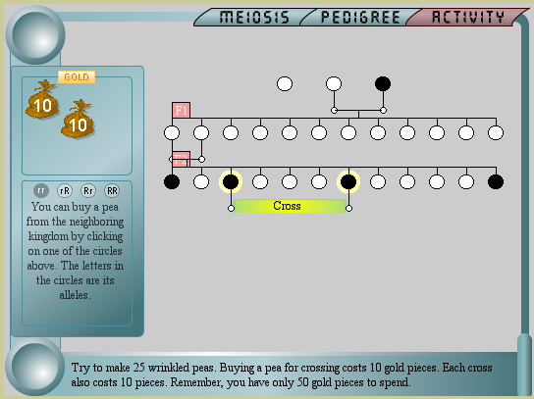
The Concord Consortium’s Mendel’s Peas Lab is the most sophisticated of the materials reviewed this far. After giving students a bit of instruction it allows them to test their knowledge in the interactive shown above. In this interactive students try to get 25 wrinkled peas by crossing breading different peas. The interactive is a great step in the right direction, but it consists of a considerable amount of text which most students will not read through. Once student’s get to the game it does not give particularly good feedback to refine their approach to playing the game and help scaffold them into a sophisticated understanding of the content. Finally, the interactive does not simulate the process of Mendel’s discovery, the objective of the game was not his objective, and the game assumes that students have already know the conclusions about how heredity works. While more engaging than the previous modules it is not anymore aligned to the national standards requirements for understanding scientific inquiry and the nature of science.

5. Punnett Squares game:
Creator: Education Development Center
http://www2.edc.org/weblabs/Punnett/punnettsquares.html
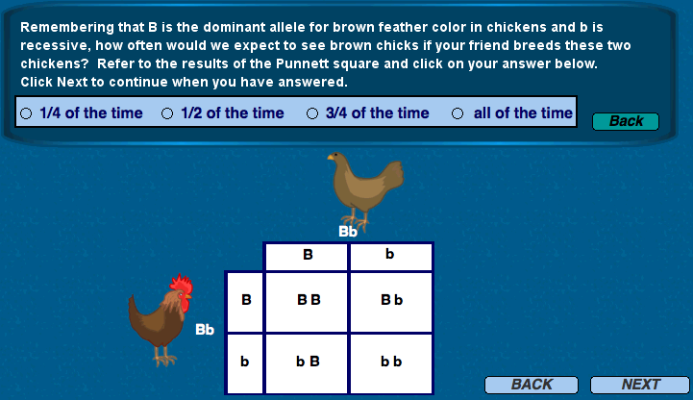
The Education Development Center’s Punnett Squares interactive, like the rest of the modules and interactives, successfully communicates the core content. However, just like the rest of the materials, it does not succeed at communicating information about the nature of science and scientific inquiry. This game is really more of a series of multiple-choice questions. This interactive also suffers from an additional burden. This interactive is written in Shockwave, which requires a browser plugin which almost no browsers come with, and is becoming increasingly difficult to find for newer browsers.

Conclusions: The existing course materials all suffer from similar sets of problems. We cannot reuse an existing content unit to deliver the instruction these students need. We will need to develop our own unit, ideally where students engage in their own process of discovery to meet national standards for the nature of science and scientific inquiry.

Interview with Middle School Science Teacher:
On Saturday October 3rd team member Trevor Owens conducted an interview with team member Margaret Chmiel. Chmiel has taught both online and face-to-face middle school science courses. For this interview Margaret’s experience and knowledge in this setting is serving as a proxy for teachers with Virginia Virtual. The findings of the interview further establish the need for a interactive that helps scaffold students abilities to conduct scientific inquiry and understand the nature of science.

Owens: Virginia Virtual has hired our development team to design a new module to help students learn about Mendelian genetics and better align instruction on the topic to both state and national standards. Your answers to our questions will help us design a interactive game to help your students learn.
Owens: Could you discuss how you would teach Mendelian genetics in a face to face class?
Chmiel: Typically students write a few notes about this and do the vocabulary words for homework. We read about/ talk about Mendel's work with pea plants and try to understand how he made sense of the data he was getting with these plants. Then the lab books that come with our textbooks typically have some related activities where students fill in Punnett squares and keep tracks of various generations for a few different organisms.
Owens: Is it difficult to translate that experience into a virtual course? If so, what specific components are difficult to transfer?
Chmiel: The hardest thing is the lack of compelling activities. I think if someone were able to capture the sort of "minds-on" strength of the pencil and paper labs, something that generated data "on the fly" and let students meaningfully analyze, that would be an incredibly useful activity.
Owens: How do you feel about the existing modules for teaching Mendelian inheritance online?
Chmiel: There are some drag-and-drop activities, but nothing that promotes what we think of as authentic scientific inquiry. I really want students to appreciate what it must have been like for Mendel to see the data coming from these pea plants are realize what a breakthrough he must have had. We typically greet Mendel's pea plants with some understanding of dominant and recessive traits and some conception of genetics. Mendel didn't have that. His ability to reason through such a complex problem lies at the heart of what we want students to understand about scientific thinking, but that isn't what the online resources capture is.
Owens: How much time do you have to devote to this subject in your course?
Chmiel: Ideally, I would spend a few days on this, but in reality, we have about 1-2 class periods for this.

Task Analysis

Given the results of the needs analysis, our team will use the Smith and Ragan approach to perform the task analysis. Applying this method will result in a list of goals highlighting what the learner (students) will know or be able to accomplish after using the proposed game.

Task Analysis Plan

Step 1: Write a learning goal

Step 2: Determine the types of learning of the goal

Step 3: Conduct an information processing analysis of the goal

Data was collected from a large Northern VA school district which scores high on questions on the Virginia SOL related to the identified learning standards to see how they address these objectives in their curriculum. By understanding the activities they use to teach these objectives, we are better able to decide the best methods to incorporate into our game design.

Step 4: Conduct a prerequisite analysis and determine the type of learning of the prerequisites.

The team will use the results from step 3 to put in order the steps required to learn each of our goals and identify what skills the learner should already possess prior to instruction.

Step 5: Write learning objectives for the learning goals and each of the prerequisites
Based on the results of step 4, the learning objectives will be revisited to ensure that they are feasible and reasonable.

Task Analysis Summary

The following task summary outlines the potential learning goals ascertained from the task analysis, an example of a strategy used to address those goals in a traditional classroom learning environment, and potential steps needed to accomplish those learning goals using our proposed game design. One of the key aspects of the curriculum analyzed is that it addresses scientific inquiry, applies content to scenarios that reinforce ideas, and gives opportunities for students to make decisions that evaluate how things are done. The game being created must address each of these needs in order to meet the needs of the students.

Task Analysis Data

Original Learning Goal

By using the design project, the learner will understand:

- That organisms reproduce and pass down genetic information to their offspring
- What genotypes and phenotypes are and the differences between them
- Factors (genetic and environmental) that effect the expression of traits
- Factors that determine whether a trait can and cannot be inherited
- Historical contributions and influences of genetic-related discoveries, past and present

Levels of learning addressed (based on Bloom’s Taxonomy)

- Knowledge (understanding key terms and definitions associated with the activity)
- Comprehension (can determine and explain results based on a particular scenario or sets of scenarios)
- Application (can use concepts learned in a new situation)
- Analysis (distinguish relevant data, find errors in reasoning, and predict outcome based on data)
- Synthesis (take data and use them to form a product, with emphasis on creating a new meaning or structure)
- Evaluation (make judgments about the value of a process or the best way to complete a task)

Processing analysis from a traditional classroom curriculum

Fairfax County Public Schools uses a scaffolding method to teach the concept of Punnett Squares. The curriculum involves a series of labs build content knowledge and then applies that knowledge in a variety of scenarios. The first lab directly related to Punnett Squares, called Mendel’s garden, uses flashcards to replicate the work of Gregor Mendel and his observations on pea plants. Designed to take two 45-minute periods, students begin by revisiting the previous lab activity that highlighted the fact that humans can pass down certain traits to their offspring and connecting that idea to other living things. They are then introduced to Mendel and his work with garden peas and the terminology used to identify the traits (phenotype, hybrid, purebred, dominant, recessive). The flashcards represent different trait variations the peas can possess.

Sample cards from Mendel’s Garden Activity © Fairfax County Public Schools

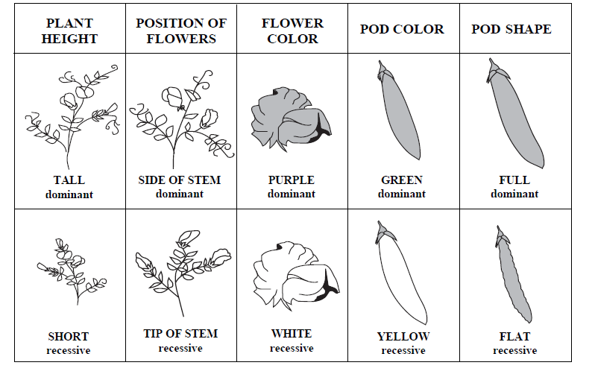
Students take a set of cards and lay them out face down on a table, and randomly select cards from each trait type. The resulting plants have a series of traits that can be dominant or recessive. Students record the trait combinations and sue what they know about dominant and recessive traits to determine which phenotypes their selections will possess. By seeing their observations recorded on paper, it also begins to show the fact that dominant traits will show (in this case as in most cases) more often since you only need one dominant gene to show the trait.

In the next lab activity, also designed to take two class periods, students are introduced to Punnett Squares, their use, terminology related to Punnett squares (homozygous, heterozygous, genotype, and mutation), and their relationship to what they have learned so far. Students are taken step by step through the process of constructing a Punnett Square, inputting the correct information, performing a cross using that information, and interpreting the results of that cross. While students are learning and practicing this process, they are growing corn plants whose seeds are the results of crossing hybrid parent plants. As a result, the seedlings will appear either green or white (green being the dominant gene and white being the recessive.) Students will predict the results of the “hybrid cross” described by growing the seeds to see the results and compare the outcome with their predictions along with their classmates. Students then analyze their results and use that data to predict the outcome of other plant and animal crosses given genetic data.

By the end of these activities, students have been exposed to material that addresses each of the learning goals presented.

Tasks needed to achieve goals

From the information processing analysis, the following order was determined to provide a best fit for our learning goals.

- Introduce concept of characteristics living things possess
- Investigate factors that influence those characteristics (heredity, environment, combination of both)
- Discuss the history of predicting those characteristics caused by heredity (Mendel and his experiments, what he saw and how he did it)
- Provide terminology relevant to describe what Mendel did and observed
- Reinforce by using activity to model the work of Mendel
- Connect work of Mendel to real word scenarios that connect the historical work of Mendel to modern applications
- Introduce Punnett Squares (Use and benefit)
- Provide terminology relevant to use Punnett Squares
- Model the use of Punnett Squares
- Provide basic scenarios practice using Punnett Squares and reinforce relevant terminology
- Incorporate real world scenarios that involve using Punnett Squares to complete a task

Learning addressed through tasks (using Bloom’s Taxonomy)

Knowledge
- Introduce concept of characteristics living things possess
- Discuss the history of predicting those characteristics caused by heredity (Mendel and his experiments, what he saw and how he did it)
- Provide terminology relevant to describe what Mendel did and observed
- Introduce Punnett Squares (Use and benefit)
- Provide terminology relevant to use Punnett Squares

Comprehension
- Investigate factors that influence those characteristics (heredity, environment, combination of both)
- Reinforce concept of inheritance by using activity to model the work of Mendel
- Model the use of Punnett Squares
- Provide basic scenarios practice using Punnett Squares and reinforce relevant terminology

Application
- Connect work of Mendel to real word scenarios that connect the historical work of Mendel to modern applications
- Incorporate real world scenarios that involve using Punnett Squares to complete a task

Analysis
- Connect work of Mendel to real word scenarios that connect the historical work of Mendel to modern applications
- Provide basic scenarios practice using Punnett Squares and reinforce relevant terminology
- Incorporate real world scenarios that involve using Punnett Squares to complete a task

Revised learning goals
After reviewing the results of step 4, it was determined that an additional learning goal that incorporated real world application was necessary in order to address aspects of the nature of science. The following learning goal was created as a solution to this problem.

By using the design project, the learner will understand:

- That organisms reproduce and pass down genetic information to their offspring
- What genotypes and phenotypes are and the differences between them
- Factors (genetic and environmental) that effect the expression of traits
- Factors that determine whether a trait can and cannot be inherited
- Historical contributions and influences of genetic-related discoveries, past and present
- Ways in which the understanding of heredity and Punnett Squares has been used by various groups in various cultures
Learner Analysis

Our team has opted to apply the Dick, Carey, and Carey method in our learner analysis. Virginia Virtual has obtained parental consent for our team to interview a sample of students currently participating in Virginia Virtual’s online student body. Due to the nature of the program, students are not in a single physical location. As a result, surveys were determined as the best way to reach these stakeholders. Students were contacted via e-mail to complete an online survey with the goal of an 80% completion rate. The survey was created using Survey Monkey (www.surveymonkey.com) where students could complete and submit it all online.

Survey Link: http://www.surveymonkey.com/s.aspx?sm=_2bxY_2fTtb27DSpAcI_2fFcZT7Q_3d_3d

Out of a total of 100 students participating in the Virginia Virtual program, 88% responded to our survey.

Learner Analysis Results

Group characteristics

- All participants are middle school students with ages ranging from 12-14. They have had experience taking science classes both in a traditional classroom and online. Most have taken general science courses in traditional elementary school classrooms (grades K-5). Most have also taken their 6th grade courses (Including general science) through Virginia Virtual. They also have experience with a variety of gaming styles, particularly puzzle/trivia, strategy, and simulation games. Students’ use an even mix of PC’s and MAC’s to participate in the program.
Prior knowledge of the topic area

- All students have taken previous science classes in the past. Most have had little exposure to aspects of the nature of science. The only category in which students received consistent instruction focused on historical figures that are associated with science achievement.
Attitudes towards the content and possible delivery system

- Students generally like their science courses and enjoy taking science online. Many reported a desire for a wider variety of activities to do to learn the material. Some of the activities students wished to have included into their instruction included:
  - Activities that involved more interaction with other class members (group assignments).
  - Lab simulations that allow them to make errors and see the results of those errors (explosions, things turning the wrong color, etc.).
  - Opportunities to do labs at home related to the content using things they have at home.
  - Games that involve concepts covered in their coursework.
  - Activities that connect the content to things currently going on in the real world, even in their communities.
Academic motivation

- By participating in the Virginia Virtual Schools Program, students must take the required science courses. The majority reported an interest in science.
Education and ability levels
- Students varied widely in their experience in taking online courses.

General learning preferences

- Students reported that they enjoy a combination of learning methods, particularly hands-on, discussions, using visuals. While discussions and the use of visuals were described as commonly used teaching methods, students reported little use of hands-on learning. They also reported that some of the topics they learned best were ones that they could relate to in some form.
Attitudes towards the Virginia Virtual program

- Students enjoy being able to take courses online, but want a wider variety of activities to learn and reinforce the material.

Virginia Virtual Online Science Survey

This survey is designed to help us create a new science activity based on the needs of you, the student. Please answer each of the 10 questions honestly. Thank you.

- Gender: Male □ Female □
- Type of computer used for Virginia Virtual curriculum: □ PC □ MAC □ Other
- Number of classes taken in virtual setting:
- Which type of online game have you played before? (Check all that apply)
□ First person action
□ Role playing
□ Puzzle/trivia
□ Strategy
□ Simulation
□ Action/Adventure

- What is one way taking science classes online is similar to taking science classes in a traditional classroom?
What is one way taking science classes online is different compared to taking science classes in a traditional classroom?
- What are some examples of activities you do or have done in your online science classes?
- When taking classes online, what types of activities do you learn the most from?
- Which of the following would use to describe the way you prefer to learn about something new (Check all that apply)?
□ I like to see visuals (seeing pictures, diagrams, demonstrations, etc.)
□ I like to read information or instructions about the topic
□ I like to be able to discuss the topic with another person
□ I like hands-on activities (labs, projects, etc.)
□ I like to listen to someone that already knows about the topic

- Which of the following topics have you learned about in Virginia Virtual science courses?
□ Historical figures that helped modern science
□ Different groups of people around the world that study science
□ How scientists make observations and test their hypotheses
□ Scientists do not always agree with each other’s ideas
□ Ideas we now accept as true were once viewed as bizarre, even crazy
□ None of the above

- If you could change one thing about the way Virginia Virtual teaches its online science classes, what would it be?
Contextual Analysis

After analyzing the data collected from the learner analysis, the following describes the proposed course of action based on our findings.
The Learning Context
The actual settings for the learning environment will be online, the student’s tower or laptop computers (PC or MAC with at least 256MB or RAM), and their homes. All students taking the science course will need to have an internet connection (DSL or broadband with an internet connection speed of at least 129 kbps), and the necessary plug-ins including Adobe Flash Player (Version 10 is the most current, but the game will be backwards compatible to version 8.) and Adobe Reader (backwards compatible to version 8). Students will be able to access the game online through a variety of browsers (Internet Explorer 6.0 or later, Mozilla Firefox 3.0 or later, and Apple Safari 3 or later).
The Performance Context
The game itself will have a both an individual and multi-player component so students have the opportunity to work together in groups while mastering the concepts based on the learning goals. Supplemental material (worksheets for data collection, pre and post assessment, etc.) will be available for download as PDF.
Since the purpose of the game is to supplement instruction, teachers will be able to monitor individual student progress throughout the game. Teachers will need to both introduce the subjects as well as provide feedback on student performance. Teacher instruction should be designed for individual and group work using the computer. Along the way, teachers will also be able to evaluate milestones students complete throughout the game (overall progress, number of tries to complete a section, etc.). These milestones will able serve as formative assessments teachers can use to address concerns throughout the process. Finally teachers will need to provide a summative assessment that will occur after the game has been completed.

Instructional Goals
The instructional goals will be arrived at by using the “ABCD” Approach described by Heinrich et al., (2002).
Analytical component | Mendelian Genetics Game
Audience | Middle school students and the instructors of Virginia Virtual Academies. These students conduct all of their learning online, and they need to have the type of science laboratory-learning experience that students in traditional schools get to experience.
Behavior | After the instruction, learners are expected to be able to analyze the phenotype and genotype of a variety of organisms based upon the products of their breeding. Students analyze heredity patterns through visual modeling by the use of Punnett squares. Punnett squares allow students to predict the frequency of traits in offspring, determine parents based upon offspring traits, and decide which parent pairs will produce desired offspring traits.
Conditions | Learners will simulate this laboratory activity online using a web interactive that will function as a digital lab/ video game.
Degree | Acceptable performance will met when students are able to successfully link parent and child generations, and apply the correct genotype to parent plants based upon analysis of their child generations
Goal | Using an online environment, students will achieve proficiency or advanced proficiency in the Virginia Standards of Learning by working with the breeding data of numerous pea plants and utilizing the observations to recognize generalizeable principles that guide heredity.

Objectives
Bloom’s taxonomic level | Objective
Knowledge | Action: Students will identify Punnett squares as one of the primary strategies used to analyze genotypes and phenotypes when studying hereditary patterns among generations of cross breedings.  Condition: Students will receive an introductory tutorial that exposes them to the Punnett square and use it as their primary tool for investigation. The game’s Mendel will demonstrate the pea plants he has been studying, and begin to organize them and their offspring into Punnett squares. This allows players to connect the organism and the phenomenon into the Punnet Square Models.  Standards: Every organism requires a set of instructions for specifying its traits
Comprehend  Apply | 2) Students will recognize (generalize) that Punnett squares can be used for any organism, and can be used to examine multiple alleles  Condition: Students will use these squares throughout the game to meet various challenges. Students will analyze pea plants, mice, flowers, guinea pigs, dogs, and chickens with a variety of hereditary combinations. For each of these items, they will see how Punnet squares can be used to analyze the complexity of various genetic traits (for instance, multiple alleles, co-dominance).  Standard: The characteristics of an organism can be described in terms of a combination of traits  3) Students will apply their understanding of Mendel’s historical work to novel problems outside of Mendel’s experimental organisms  Condition: Students will play the game first as Mendel’s apprentices, and later move on to make exciting findings on their own. In the game, Mendel will model his analysis of pea plants. Afterward he will ask players to select their own organisms and provide them with “just in time” information to explain what the novel problem is with the selected organism.  Standard: Tracing the history of science can show how difficult it was for scientific innovators to break through the accepted ideas of their time to reach the conclusions that we currently take for granted
Synthesize | 4) Students will be able to generate tentative observations and use these to design targeted cross-breeding investigation in order to yield more specific data in increasingly more complex situations  Condition: Students will be able to choose from multiple organisms in the game. As they test more organisms, they progress in the game, receiving points and unlocking new challenges. Organisms will be selectable from an in-game menu with some description noting the difficulty of the particular organism. “Testing” will involve a Punnet environment where players will place parents to see their offspring results. Upon examining those results, players will take online notes, making predictions about the parents’ genotype. Eventually, players will need to finalize their genotype assignments.  Standard: Scientific investigations sometimes result in new ideas and phenomena for study, generate new methods or procedures for an investigation, or develop new technologies to improve the collection of data
Evaluate | 5) After performing appropriate cross-breeding investigations, students will be able to defend their hypothesis about heredity patterns within a select organism.  Condition: Students will enter a phase of the game in which they are presenting and defending their findings to Mendel. Students will select (from several options) the conclusions they want to present to Mendel and drag and drop the appropriate date to defend their conclusion. Data for this game comes from the players’ finding through the game. Mendel then gives students feedback about how solid their arguments are.  Standard: It is part of scientific inquiry to evaluate the results of scientific investigations, experiments, observations, theoretical models, and the explanations proposed by other scientists

Description of Learning Environment
The game resides in a larger course management system. The game itself will be a direct learning environment because we do want all students to develop similar skills and aptitudes. However, users will be allowed freedom to pursue different cross-breeds and direct their study to a certain degree as we will use indirect teaching strategy. Learners will also utilize active participation rather than active reception.
The primary characteristic of this learning environment is that of a learning game or simulation. Gredler (2004) describes simulations as “evolving case studies that allow participants to examine issues and problems that arise in a specific situation. This case-based nature of simulations is an ideal medium for presenting a historical situation such as Menel’s experiments. More specifically, our environment can qualify as an instructional game, a subset of instructional simulations. According to Brown and Green, games have the benefit of keeping learners engaged in what might otherwise feel like repetitive tasks. Games can provide a relaxed atmosphere for learners. Games allow learners to practice or refine knowledge; identify games or weaknesses in knowledge or skills; and illustrate and develop new concepts or principles (p. 186). In addition, this activity can be characterized as a hypothesis testing learning environment (p. 197)
Additionally, the learning environment allows designers to utilize some of the learning principles embodied in video games (Gee, 2003). For instance:
Gee’s Learning Principle | Manifestation in Mendelian Genetics Game
Active, Critical Learning principle (p. 207)  All aspects of the learning environment (including the way in which the semiotic domain is designed and presented) are set up to encourage active and critical, not passive, learning | Students jump in to real-life situations and applications of genetic principles right away. By couching the game in a historical context, students come away with scientific content in tandem with an understanding for the nature of science.
Psychosocial moratorium principle (p. 207)  Learners can take risks in a space where real-world consequences are lowered. | Students can “play around” with various crosses as many times as they would like with targeted feedback until the student feels she or he has mastered the content enough and is ready to be assessed to move on to the next challenge. Students don’t need to move on to more challenging content until they are comfortable with the previous content. Students can also intentionally “make mistakes” in order to pursue their own questions and satisfy their own curiosities.
Probing Principle (p. 209)  Learning is a cycle of probing the world; reflecting in and on this action and, on this basis, forming a hypothesis; reprobing the world to test this hypothesis; and then accepting or rethinking the hypothesis. | This principle is incredibly suited to the scientific process, especially the historical picture of what Mendel did. This principle is central to our game’s design.
Situated Meaning Principle (p. 209)  The meaning of signs are situated un an embodied experience. Meanings are not general or decontextualized Whatever generalizeable meaning comes to have is discovered bottom up via embodied experiences. | Students are introduced to fundamental genetics concepts (genotype, phenotype, generations, crosses, dominant traits, receive traits, hybrid traits, alleles) in the context in which these key ideas were first conceived: the experiments that first lead to their understanding. Students will then be able to apply these concepts to other situations. These terms and ideas are placed directly in the contexts in which scientists use them.
Discovery Principle (p. 211)  Overt telling is kept to a well-though-out minimum, allowing ample opportunity for the learner to experiment and make discoveries. | Students will receive guidance and feedback, but will be expected to identify patterns and draw conclusions on their own.

Activities
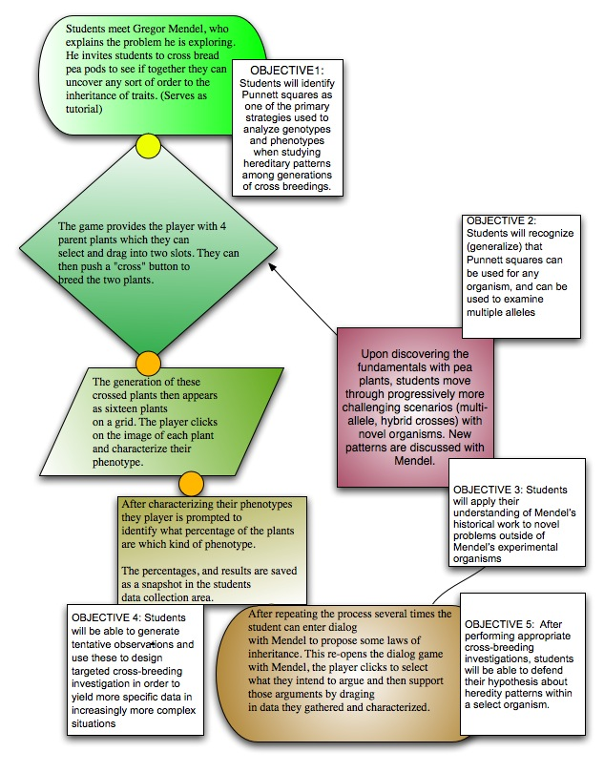

Learner Assessment
There will be two types of learner assessments:
- The game as assessment- One of the strengths of using a video game format is that it will provide learners with an ongoing assessment of her understanding. She will have ongoing feedback and opportunities to test her knowledge and improve understanding. The learning design graphic organizer above illustrates the opportunities for iteration and feedback.
- A Virginia SOL exam: This will be an “objective” test that measures content knowledge about genetics, alleles, and heredity. This will be administered as a pretest and post-test to determine a change in understanding. Additionally, we will administer pre-post tests of constructed response asking students to tell a story of scientific inquiry.

Sample questions:
1) Examine the phenotypes of the parental (P) and generation 1 (F1) offspring. The tall plant (T) is dominant and the short plant (t) is recessive.
If two of the offspring (F1) were crossed and had 6 offspring, what would their predicted phenotypes and genotypes be for that generation (F2)? Label each. Offspring with its correct phenotype and genotype.
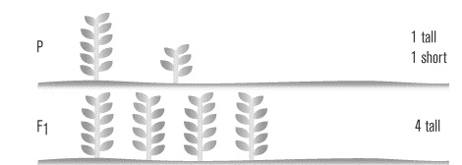

- Mouse coat color is polygenetic (controlled by multiple genes) represented by B and C in the diagram below. Study the diagram. What color would you expect the mouse to be if:
  - Both genes were recessive?
  - Both genes were heterozygous?
  - Both genes were dominant?

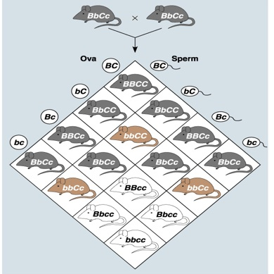

Formative Assessment
Several methodologies were employed as a formative assessment and can be seen in this document. For instance, a Needs Assessment (Page 3) presents Virginia Virtual’s challenge in teaching inheritance and Mendel’s genetics, thus outlining the service we hope to provide. A survey of existing web materials presents the landscape of how others have approached similar problems, and shed light on what this project will need to do differently (page 6). A Task Analysis (page 11) unpacks what the learner will need to do and a learner analysis (page 15) provides insight into where the learners are in terms of understanding and comprehension prior to the activity.
For further analysis of the Mendelian genetics game as it is being built, we propose utilizing the Dick, Carey, and Carey approach:
Step  Approximate time required  Leader | Description of activity
One-on-one  (5 business days)  Trevor | The paper prototype will be assessed in one-on-one assessments with three (3) Virginia Virtual Science teachers and two (2) classroom, face-to-face teachers in Fairfax County. The goal will be to make sure that the presentations focuses on core biology content in a manner that teachers will be comfortable with.  Totals tested: 5 teachers
Small Group:  (4 business days)  Marjee | A functioning alpha will focus primarily on usability questions, including finding technological bugs that may emerge via a variety of computer platforms. The functioning alpha will be used with three (3) Virginia Virtual classrooms and one (1) face-to-face classroom Fairfax County utilizing a computer lab. Classrooms include students and their teachers.  Totals tested: 4 teachers; 100 students
Field Trial  (2 business days)  Ammos | A beta version of the game will be distributed among two (2) classes of the Virginia virtual school to perform final, large scale usability (for instance, making sure an API communicates with teachers), “learn-ability” testing (are students able to understand what is going on? Are students able to connect game concepts to concepts covered in the rest of the course?), making sure reasonable accommodations are made for various learners needs, and uncovering any final, hidden technological bugs. Classrooms include students and their teachers.  Totals tested: 2 teachers, 50 students

Summative Evaluation Plan
Smith and Ragan’s approach (1997) was used to create the following summative evaluation plan and is outlined using steps from that strategy.
Goals of the Evaluation:
Virginia Virtual teachers and staff were consulted to compile a list of questions to be answered by the summative evaluation plan. The following is a list of questions derived from those meetings.
- Do the learner activities coincide with the instructional goals?
- Do the instructional materials stimulate ongoing understanding of the topics and concepts?
By using the online interactive created by of instructional design firm has the following occurred?
- Do students have a basic understanding of Mendelian genetics?
- Can students use terminology correctly?
- Can students use Punnett Squares correctly to identify genotypes and phenotypes?
- Can students collect data using Punnett squares on parent and offspring generations?
- Can students use Punnett square data to predict the outcome of breeding certain organisms given particular traits?
- Can students use Punnett square data to determine the parents of offspring given particular traits?
- Have students demonstrated an increased understanding of the connection between Mendelian genetics and real-life problems?
- Can students answer questions on Mendelian genetics found on the Virginia SOL successfully (with at least 80% accuracy)?
- Do students rate their experience using the online interactive as positive?
- Are students able to access the online interactive easily?
- Does the online interactive flow in a way that makes sense to the user?
Indicators for Success
Evidence of the impact of the instructional program will be gathered through student usage logs collected while students played the online interactive (completion rates, time spent using the interactive, mastery of tasks in the game), scores from portions of the Virginia SOL that address Mendelian genetics, and interviews of student and teacher participants (perceptions of the game and its effectiveness).
Orientation of the Evaluation
A mixed-methods approach (both quantitative and qualitative data) was determined to be the most effective evaluation approach. Quantitative data will be collected and analyzed from all student participants. Qualitative data will come from a random sample of student and instructor participants that will be interviewed via phone or in person.
Design of the Evaluation
Data will be collected in several stages. Student data will be collected through actual game usage, pre and post tests which will address Medelian genetics questions from the Virginia SOL, and student/teacher interviews from a random sample of the participants.
Evaluation Measures
Test measures will reflect genetics questions and topics addressed in the game interactive. Transcriptions of student/teacher interviews will be measured using open coding to identify themes.

